COPD Assessment Test (CAT)
- Follow this path: More Activities> Documentation Flowsheets
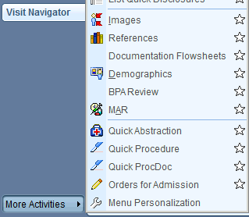
- Add the CAT (‘T AMB COPD’) to the Doc Flowsheets:
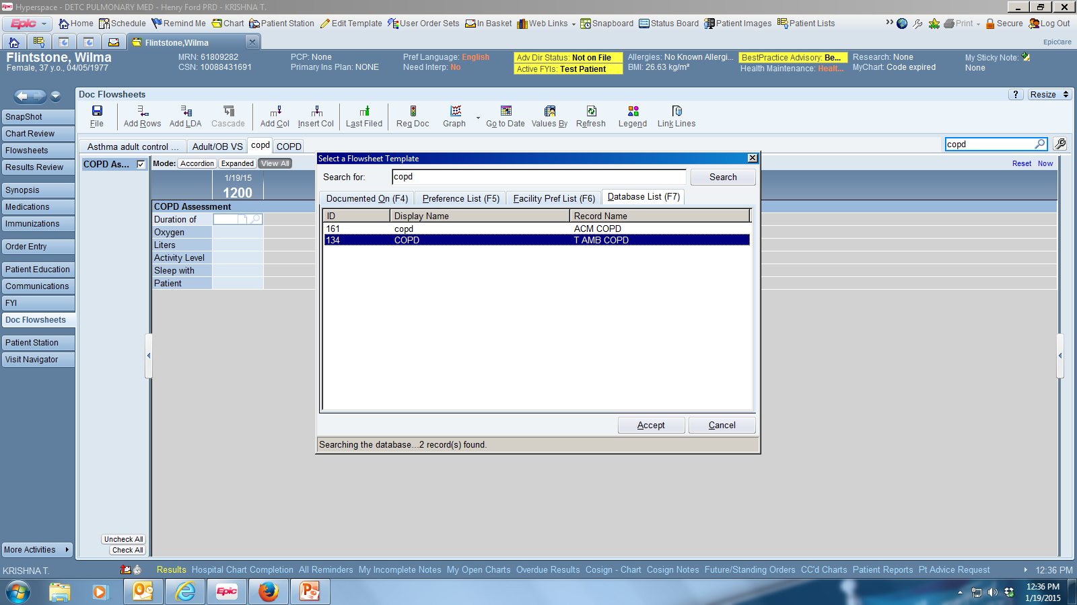

- Fill out the CAT
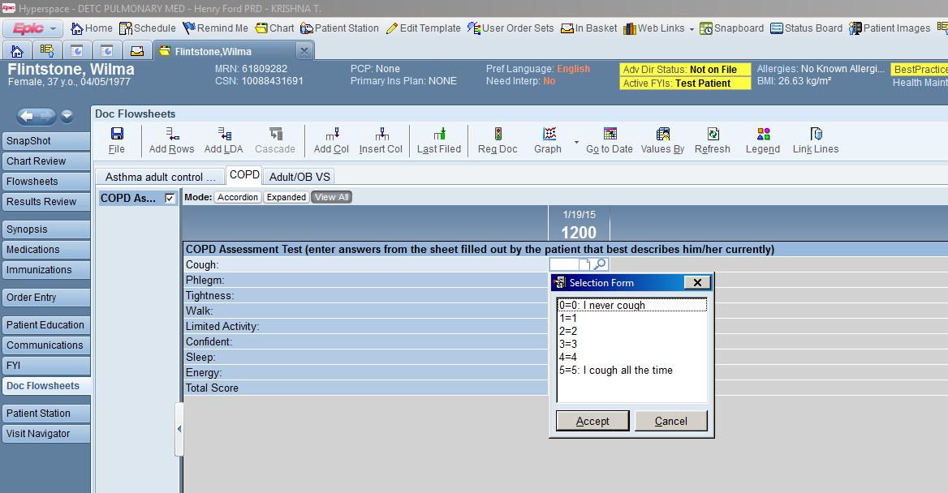

- To add this test to your notes, highlight all of the cells and then right click. Select New Note:
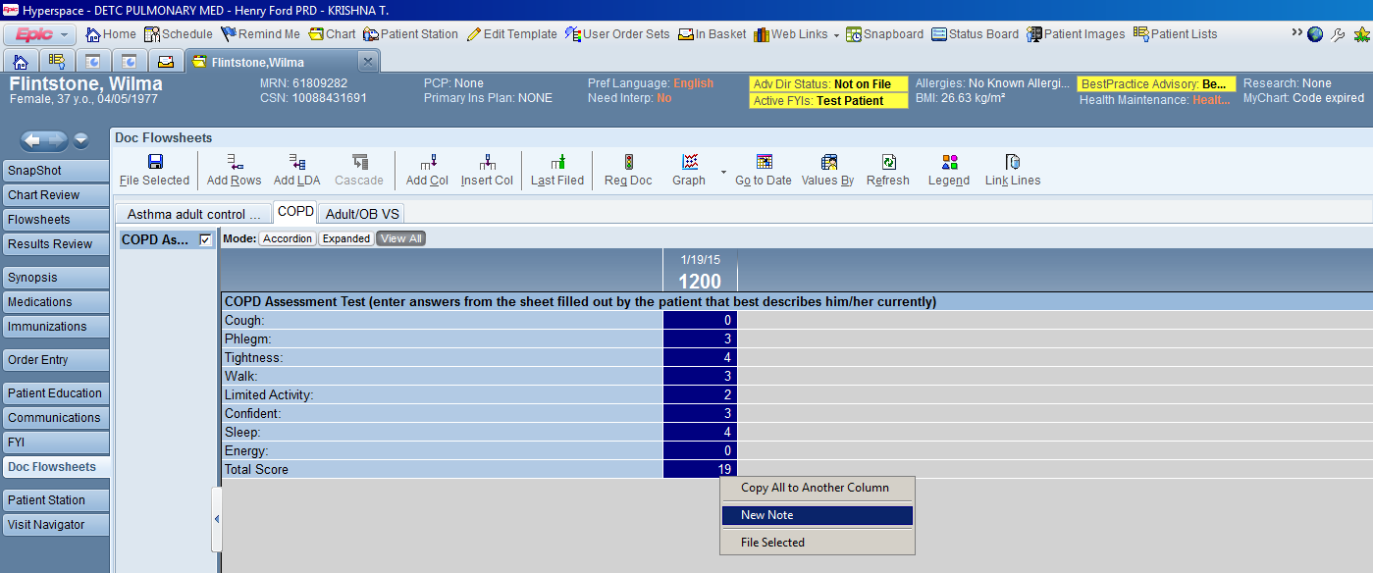

- The Flowsheet Notes box will appear, click Insert Data and then Pend the note (no problem if you ‘sign’ the note, it will show up as a separate note in your visit navigator):
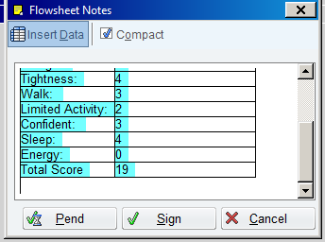

- Go to the Visit Navigator, to the Progress Note section. You will see a note started, with the Test in the note. Click Edit to complete your note:
