Henry Ford  Health System | Policy Name/Subject: HELIOS Intensive Care Unit (ICU) Protocol for Pain, Agitation, and Delirium for patients on the ventilator (PAD)
 | Document includes: Policy Procedure X Other: Protocol
 | Applies to: All HFHS Business Unit: Service Line: Dept:
 | Category: | Current Approval Date:
 | Owner (Title): | Approver (Title):
 | Last Revision Date & Key Change(s):
 | Key Word(s):

PURPOSE:
The purpose of the pain, agitation, and delirium (PAD) protocol is to:
- Allow bedside clinicians to manage pain, agitation and delirium for the adult ventilated ICU patient
- Guide the provider when ordering medications for pain, agitation and delirium.
- Provide appropriate and safe dosing and monitoring guidelines.
- Decrease adverse drug events related to medications in this protocol

The goal of the protocol is to:
- Assess and treat pain and agitation using the Critical Care Pain Observation Tool (CPOT).
- Maintain CPOT score less than 2.
- Decrease the incidence of delirium by minimizing benzodiazapam use.
- Treat delirium in ventilated patient with appropriate medications.
- Decrease ventilator time, decrease ICU length of stay, and provide a means to adjust medications based on the patient’s CPOT.

POLICY:
- The provider will order the medications outlined in this protocol when pain and sedation management is needed for the ventilated patient.
- CPOT will be assessed minimally every 4 hours.
- RASS will be assessed minimally every 4 hours; If the patient is on continuous sedation medication the RASS will be assessed minimally every 2 hours.
- Confusion Assessment Method for the ICU (CAM-ICU) will be assessed minimally every 12 hours.
- The nurse will follow the dosing guidelines in this protocol when the provider orders medications.

EXCLUSIONS:
- Patients who are pharmacologically paralyzed.
- Patients whose life support is being withdrawn.

DOCUMENTATION:
- CPOT, RASS and CAM-ICU will be documented in the electronic health record (EHR) under VS Complex
- All drugs are to be recorded in the EHR on the medication administration record.
- Continuous infusions are to be documented with dosage and infusing rate/volume in the flowchart portion of the electronic medical record.

Procedure to maintain CPOT 2 or less

Provider will order fentanyl, morphine or hydromorphone upon inititation of PAD protocol.

FENTANYL Intermittent Dosing
CPOT greater than 2 | CPOT 0 – 2
Intermittent dosing  - Fentanyl 25 mcg IVP x1  - Reassess CPOT in 10 minutes, if greater than 2 give Fentanyl 50 mcg IVP  - Reassess CPOT in 10 minutes, if greater than 2 give Fentanyl 75 mcg IVP.  - After 3 consecutive doses at 10 minute intervals, change to continuous fentanyl infusion.  - The dosage given that achieves a CPOT of 2 or less will be the subsequent dosing of intermittent fentanyl. | Intermittent dosing  No dose required
Continuous dosing  - May bolus with 25mcg IVPx1 while waiting for fentanyl infusion  - Start infusion at 25 mcg/hr  - Reassess CPOT at 10 minute intervals until goal CPOT is reached.  - For each CPOT score of greater than 2 increase fentanyl infusion by 25 mcg/hr  - Maintenance dose will be achieved once CPOT score is 2 or less.  - Maximum dose of fentanyl is 300 mcg/hour  - If that dose is reached and CPOT remains greater than 2, add the ordered intermittent sedation medication. | Continuous dosing  CPOT 1-2  Maintain dose  CPOT 0  Decrease infusion by 50%
MORPHINE
CPOT greater than 2 | CPOT 0 – 2
Intermittent dosing  - Morphine 2 mg IVP x 1  - Reassess CPOT in 10 minutes if greater than 2 give Morphine 4 mg IVP x 1  - Reassess CPOT in 10 minutes if greater than 2 give Morphine 6 mg IVP x 1.  - After 3 consecutive doses at 10 minute intervals, change to continuous morphine infusion.  - The dosage given that achieves a CPOT of 2 or less will be the subsequent dosing for intermittent morphine. | Intermittent dosing  No dose required
Continuous dosing  - May bolus with Morphine 2 mg IVP x 1 while waiting for the morphine infusion.  - Start infusion at 2 mg/hr.  - Reassess CPOT at 10 minute intervals until goal  CPOT is reached.  - For each CPOT score of greater than 2 increase Morphine drip by 2 mg/hr.  - Maintenance dose will be achieved once CPOT score is 2 or less.  - Maximum dose for Morphine is 20 mg/hr.  - If that dose is reached and CPOT remains greater than 2, add the ordered intermittent sedation medication. | Continuous dosing  CPOT 1-2  Maintain same dose  CPOT 0  Decrease infusion by 50%

HYDROMORPHONE
CPOT greater than 2 | CPOT 0 – 2
Intermittent dosing  - Hydromorphone 0.5 mg IVP x 1  - Reassess CPOT in 10 minutes if greater than 2 give Hydromorphone 1 mg IVP x 1.  - Reassess CPOT in 10 minutes if greater than 2 give Hydromorphone 1.5mg IV x 1.  - After 3 consecutive doses at 10 minute intervals, change to continuous dilaudid infusion.  - The dosage given that achieves a CPOT of 2 or less will be the subsequent dosing of hydromorphone. | Intermittent dosing  CPOT 1 - 2  No dose required
Continuous dosing  - May bolus with hydromorphone 0.5 mg IVP x 1 while waiting for infusion  - Start infusion at 0.5 mg/hr.  - Reassess CPOT at 10 minute intervals until goal CPOT is reached.  - For each CPOT score of greater than 2 increase drip by 0.2mg/hr.  - Maintenance dose will be achieved once CPOT score is 2 or less.  - Maximum dose for Hydromorphone is 3 mg/hr.  - If that dose is reached and the CPOT remains greater than 2, add the ordered intermittent sedation medication. | Continuous dosing  CPOT 1 - 2  Continue same dose  CPOT 0  Decrease infusion by 50%

Sedation Medication ADDED to Continuous Pain Medication to achieve a CPOT of 2 or less

Patient must be maximized on continuous pain medication before going to sedation medication.

Provider will order midazolam or lorazepam upon order initiation.

Midazolam Intermittent Dosing
CPOT greater than 2 | CPOT 0 – 2
Intermittent dosing  - Midazolam 1 mg IVP x 1  - Reassess CPOT in 10 minutes if greater than 2 give Midazolam 2 mg IV x 1.  - Reassess CPOT in 10 minutes if greater than 2 give Midazolam 4 mg IVP x 1.  - The dosage given that achieves a CPOT of 2 or less will be the subsequent dosing of intermittent midazolam  - If CPOT remains greater than 2 notify physician and be prepared to discuss  - CAM assessment  - Delirium treatment  - Underlying medical causes for elevated CPOT. | Intermittent dosing  No dose required

Lorazapam Dosing
CPOT greater than 2 | CPOT 0 – 2
Intermittent dosing  - Lorazepam 1 mg IV x 1  - Reassess CPOT in 10 minutes if greater than 2 give Lorazepam 2 mg IV x 1  - Reassess in 10 minutes if greater than 2 give Lorazepam 4 mg IV x 1.  - The dosage given that achieves a CPOT of 2 or less will be the subsequent dosing of lorazepam.  - If CPOT remains greater than 2 notify physician and be prepared to discuss  - CAM assessment  - Delirium treatment  - Underlying medical causes for elevated CPOT | Intermittent dosing  No dose required

PATIENTS WHO ARE ON CONTINUOUS SEDATION INFUSIONS WILL HAVE SEDATION VACATIONS DONE BASED ON PARAMETERS BELOW:

SEDATION VACATION

No Sedation Vacation (Exclusions) | Yes Sedation Vacation  Shut off all pain medication infusions and sedation infusions until any parameters listed below are met  Sedation is re-started at 50% if any of the parameters are met  If no parameters stop sedation infusion and begin using CPOT to titrate pain infusion down
- Active seizures  - Alcohol withdrawal  - RASS > 2  - On paralytics  - Active myocardial ischemia  - Increased intracranial pressure | - RASS ≥ 2  - Respiratory Rate > 35  - Oxygen Saturation < 88%  - Respiratory Distress  - Acute Cardiac Arrythmia

INDIVIDUAL PROVIDER ORDERS WILL BE WRITTEN BASED ON THE GUIDELINES BELOW FOR:

- Continuous Sedation Infusions
- Delirium Treatments

CAM NEGATIVE PATIENTS
The provider will write an order for either propofol or midazolam if a sedation medication is needed.

Propofol Infusion Dosing
RASS greater than 0 | RASS less than -2
- Begin Infusion at 5mcg/kg/min  - Reassess RASS in 10 minute intervals.  - If RASS is greater than 0 increase infusion by 5mcg/kg/min.  - Maximum dose is 80 mcg/kg/min.  - If this dose is reached and RASS is greater than 0, future dosing must be done based on physician orders and the protocol cannot be used. | - Titrate infusion down by 5 mcg/kg/min

Midazolam Infusion
RASS greater than 0 | RASS less than -2
- Begin Infusion at 2 mg/hr.  - Reassess RASS in 10 minute intervals.  - If RASS is greater than 0 increase infusion by 2 mg/hr.  - Maximum dose is 40 mg/hr.  - If this dose is reached and RASS is greater than 0, future dosing must be done based on physician orders and the protocol cannot be used. | - Titrate infusion down by 2 mg/hr.

CAM Positive Patients will begin Delirium Management
The provider will write for propofol infusion for patients requiring continuous sedation medications AND are CAM +.
Delirium Management

- RASS Goal is -2 to 0
- Continue with continuous pain infusion.
- Add propofol for sedation medication
- Consider adding Quetiapine 50 mg OG/NGT every 12 hours for 10 days. May be increased by 50 mg every 24 hours to a maximum of 200 mg every 12 hours.
- Medication Review in order to remove any delirium causing medication
- 12 lead EKG for QTc daily if receiving a neuroleptic medication (quetiapine) and place in patient’s medical record (blue chart)

Propofol Infusion Dosing
RASS greater than 0 | RASS less than -2
- Begin Infusion at 5mcg/kg/min  - Reassess RASS in 10 minute intervals.  - If RASS is greater than 0 increase infusion by 5mcg/kg/min.  - Maximum dose is 80 mcg/kg/min.  - If this dose is reached and RASS is greater than 0, future dosing must be done based on physician orders and the protocol cannot be used. | - Titrate infusion down by 5 mcg/kg/min

CRITERIA TO USE DEXMEDETOMIDINE:

Mechanically ventilated ICU patients that meet ALL of the following criteria:

- Pain and Sedation medications cannot be stopped and have delayed the ventilator weaning process.

- Failure to wean because of hyperactive delirium

- Patient is hemodynamic stable

- Absence of acute stroke, dementia, liver failure (Child-pugh class C), renal failure with confusion due to uremic encephalopathy

Dexmetetomidine Infusion Dosing
Infusion length is 24 hours

RASS greater than 0 | RASS less than -2
- Begin Infusion at 0.5mcg/kg/min  - Decrease any sedative infusions by 50% at the time that Dexmetetomidine is started and every 30 minutes decrease by 50% until sedation medications are off.  - Continue to assess and treat CPOT per protocol.  - Reassess RASS in 15 minute intervals.  - If RASS is greater than 0 increase infusion by 0.1mcg/kg/min.  - Maximum dose is 1.5mcg/kg/min.  - Once RASS is -2-0 that is the maintenance doseIf this dose is reached and RASS is greater than 0, future dosing must be done based on physician orders and the protocol cannot be used. | - Titrate infusion down by 0.1mcg/kg/min.

DEXMEDETOMIDINE AND WEANING THE VENTILATOR
- Do not turn off dexmedetomodine for sedation vacations
- Dexmedetomidine does not cause respiratory depression and can be used during spontaneous breathing trials
- You can safely extubate on dexmedetomidine
- Once patient is extubated decrease infusion by 0.1mcg/kg/hr every 10 minutes until 0.2 mcg/kg/min is reached. Keep this rate until bag is empty then discontinue.

Sedation & Pain Scales
Richmond Agitation Assessment Scale ( RASS)

RASS Score | Description | Definition
-5 | Un-arousable | No response to voice or physical stimulation
-4 | Deep sedation | No response to voice, but movement and eye opening to physical stimulation
-3  -2  -1 | Moderate sedation  Light sedation  Drowsy | Movement or eye opening to voice (but no eye contact)  Briefly awakens with eye contact to voice  (less than 10 seconds)  Not fully alert, but has sustained awakening (eye opening/eye contact to voice for 10 seconds)
0 | Alert and calm
+1 | Restless | Anxious but movements not aggressive vigorous
+2  +3 | Agitated  Very agitated | Frequent non-purposeful movement,  fights ventilator  Pulls or removes tube(s) or catheter(s); aggressive
+4 | Combative | Overtly combative, violent, immediate danger  to staff

Noxious stimulus:
Suctioning OR after 5 seconds of vigorous orbital, sternal, or nail-bed pressure OR when vigorously pinched
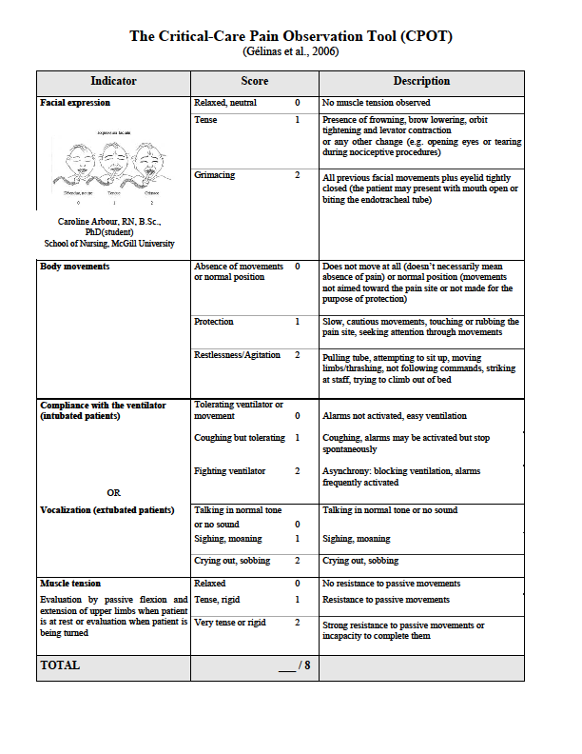

Table 5
Causes of agitation in critically ill patients

Physiologic | Chemical | Pharmacologic | Emotional | Environmental
Pain | Hypoxia | Anesthetic agents | Anxiety & panic | Lack or windows
CNS insults | Hypercapnia | Analgesics (e.g., opioid analgesics) | Fear & terror | Room temperature
Mechanical ventilation | Hypoglycemia | Antiparkinsonian medications (levodopa) | Hallucinations | Drafts
Dyspnea | Liver failure | Anticonvulsants (e.g., barbiturates) | Preexisting psychological problems | Odors
Nausea | Renal failure | Antihistamines | Fragmented thought processes | (Continuous) Light
Constipation | Electrolyte Imbalances | Antibiotics (e.g., fluroquinolones) | Physical restraints | Noise
Thirst & Hunger | Withdrawal from drug or alcohol | Bronchodilators | Need to move & stretch | Sleep deprivation
 |  | Cardiac (e.g., beta blockers, methyldopa, digoxin) | Feeling of being confined | Altered circadian rhythms
 |  | Corticosteroids  immunosuppresant agents | Loss of control
 |  | H2-receptor antagonists
 |  | Lithium
 |  | Sedatives (benzodiazepines)

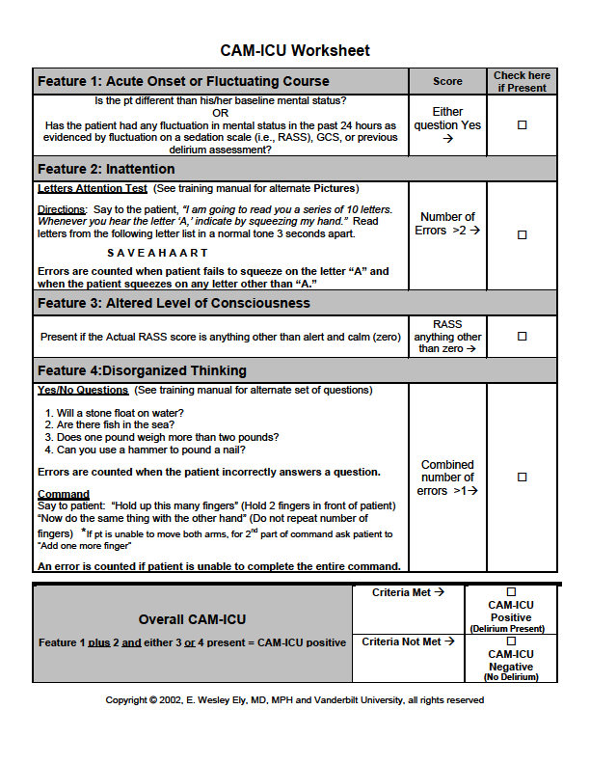

Reference(s)/Source(s)
REFERENCES 2010:
Barr J, Fraser GL, Puntillo K, et al. Clinical Practice Guidelines for the Management of Pain, Agitation, and Delirium in Adult Patients in the Intensive Care Unit. Crit Care Med 2013; 41(1): 263-306
Girard, TD, Kress, JP, Fuchs, BD, Thompson, JW et al. (2008) Efficacy and safety of a paired sedation and ventilator weaning protocol for mechanically ventilated patients in intensive care (Awake and Breathing Controlled trial): A randomized controlled trial. Lancet, 371, 126-134.
Kress, JP, Pohlman, AS, O”Connor, MF & Hall, JB, (2009).Daily interruption of sedative infusions in critically ill patients undergoing mechanical ventilation.The New England Journal of Medicine, 342 (20), 1471-1477.

Attachment(s) - Only use attachments when links are not possible.

