Adding LOS codes
Click on Wrench in the LOS section
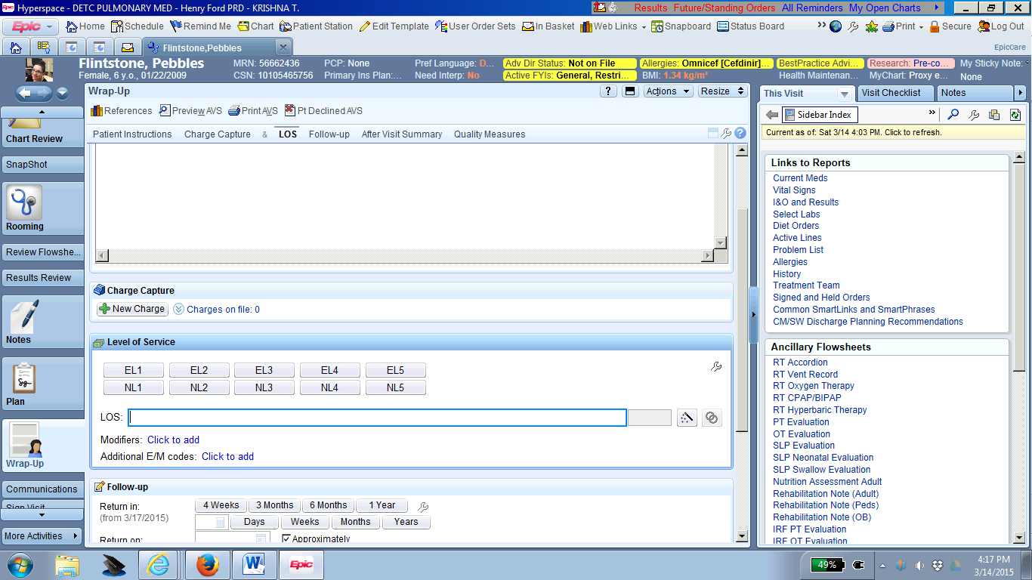

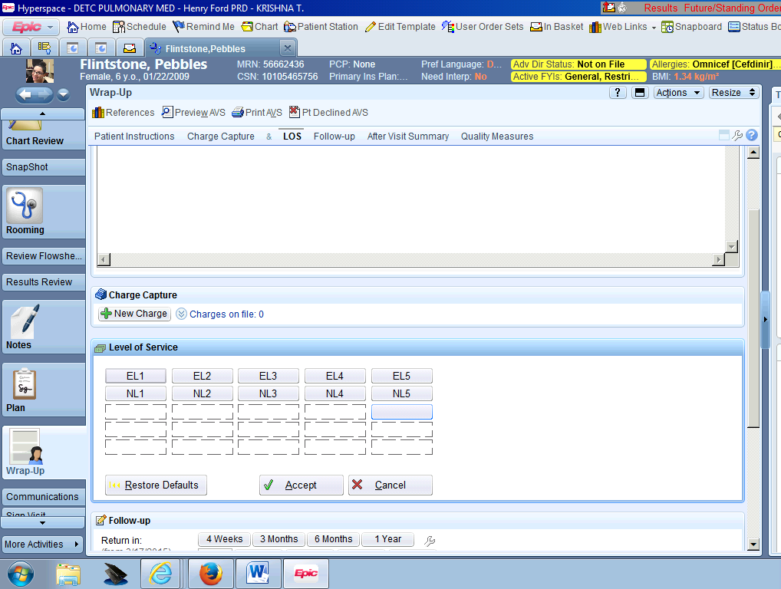
Click on location for the new shortcut.
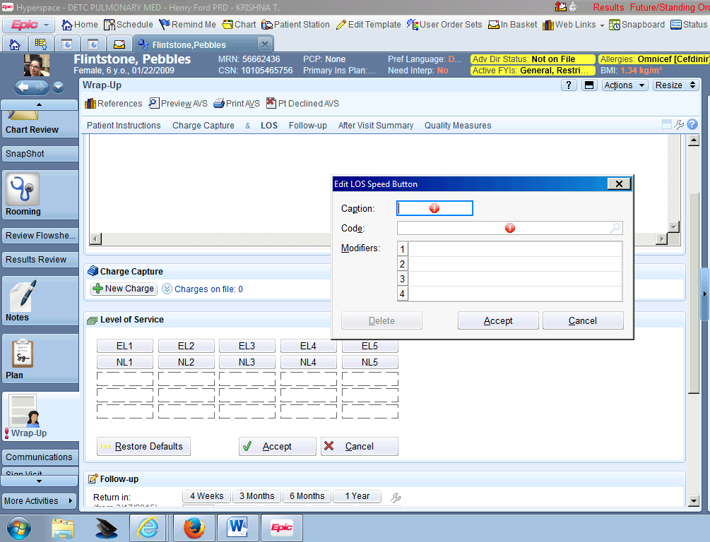
Enter ‘new’ in the Code field

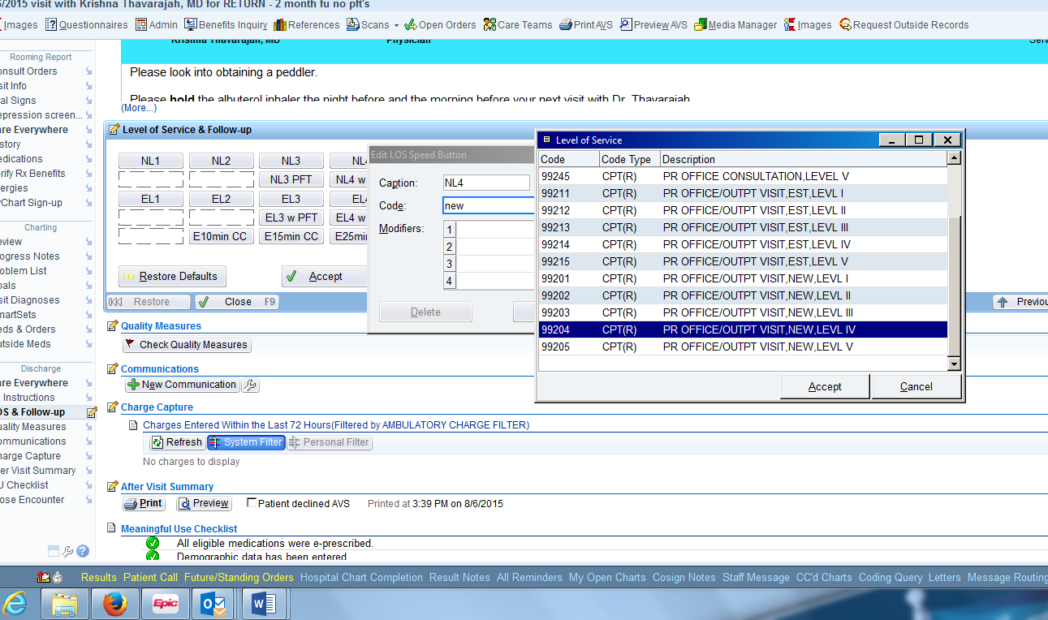
Select the corresponding option (new level IV)
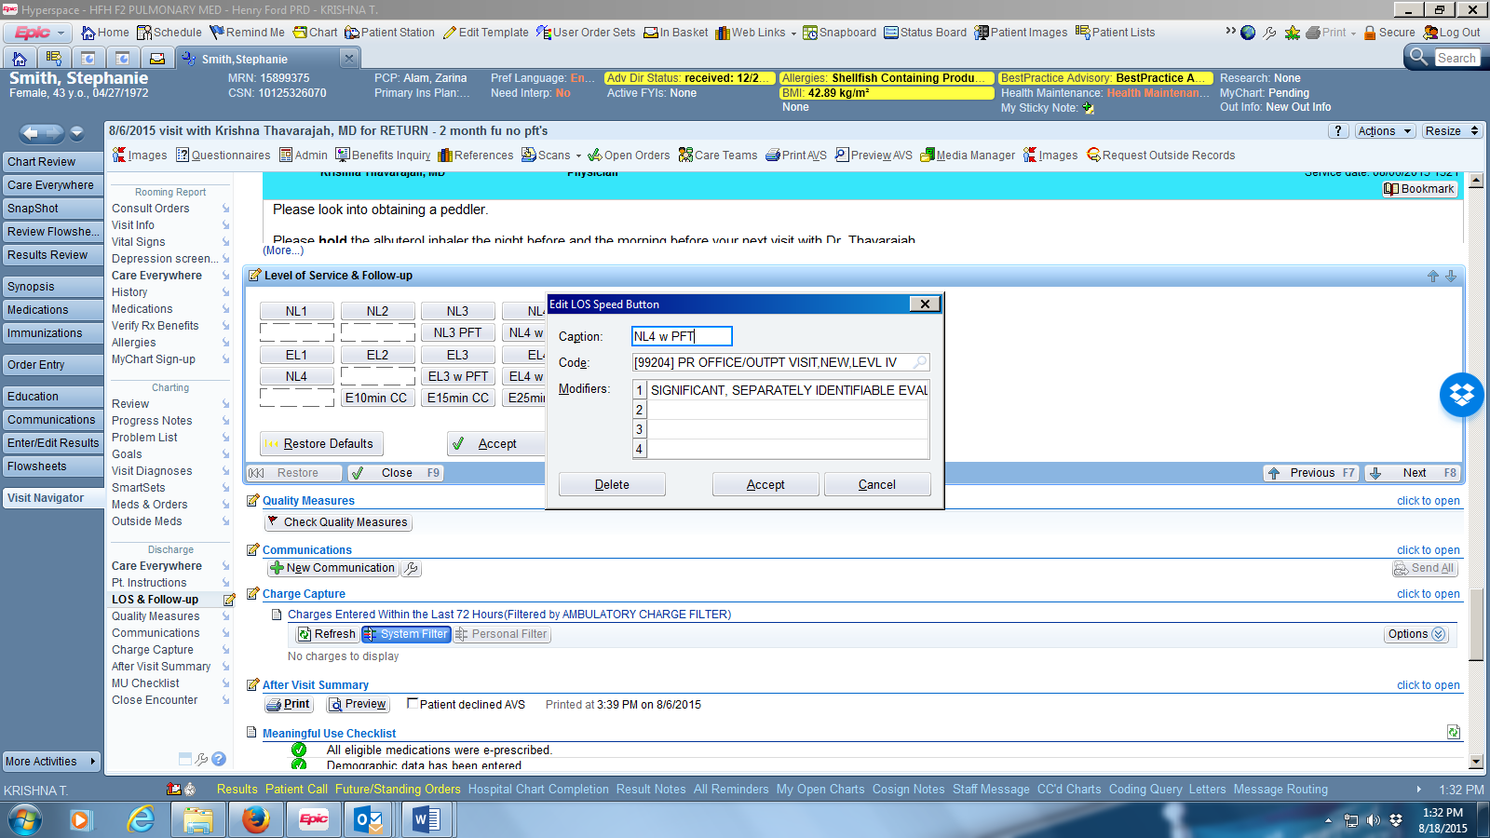
Type ‘25’ in the Modifier section and click on Accept

I have also created additional established level visits buttons to correspond with visits when I bring a patient back to discuss results but I am not examining them (coordination of care and counseling). YOU MUST DOCUMENT IN YOUR NOTE: ’I spent ___minutes with the patient, the majority in coordination of care and counseling.’
This only includes face to face time of the physician (CANNOT include MA or nursing time)

CPT code | Code | Time spent | Caption Suggestion
99211 | PR Office/Outpt Visit, Est, LVL I | 5 min | Est5min
99212 | PR Office/Outpt Visit, Est, LVL II | 10 min | Est10min
99213 | PR Office/Outpt Visit, Est, LVL III | 15 min | Est15min
99214 | PR Office/Outpt Visit, Est, LVL IV | 25 min | Est25min
99215 | PR Office/Outpt Visit, Est, LVL V | 45 min | Est45min

