FeNO in Asthma Management and Guiding Biological Therapy

1. Purpose:
This protocol provides guidance on incorporating FeNO (Fractional exhaled Nitric Oxide) measurements into clinical decision-making for asthma management in adult patients. It focuses on using FeNO to adjust inhaled corticosteroids (ICS) and determine the appropriateness of biological therapy.

2. Clinical Context:
FeNO is a non-invasive marker of airway eosinophilic inflammation. It can assist in assessing asthma control, adjusting ICS therapy, and guiding decisions on biological therapy. FeNO should be interpreted alongside clinical symptoms, lung function tests, and patient history.

3. Protocol Steps:

FeNO Levels and Interpretation in Asthma Management
FeNO Level (ppb) | Clinical Interpretation | Recommended Actions
< 25 ppb | Low FeNO | - Low likelihood of eosinophilic inflammation.  - Consider alternative diagnoses.  - Avoid or reduce ICS therapy unless otherwise indicated.
25-50 ppb | Intermediate FeNO | - Possible eosinophilic airway inflammation.  - Assess in conjunction with clinical symptoms and spirometry.  - Consider ICS therapy or dose adjustment.
> 50 ppb | High FeNO | - High likelihood of eosinophilic inflammation.  - Initiate or escalate ICS therapy.  - Monitor for response to ICS treatment.

Reducing ICS Therapy Based on FeNO
FeNO Level (ppb) | Considerations for ICS Reduction
< 25 ppb | - Safe to reduce ICS if asthma symptoms are controlled.  - Regularly monitor FeNO to detect any increase in inflammation.
25-50 ppb | - Step-down ICS cautiously, assessing clinical stability and FeNO trends.  - Monitor closely for any symptom deterioration.
> 50 ppb | - Do not reduce ICS. High FeNO suggests ongoing inflammation that requires continued or increased ICS therapy.

Guiding Biological Therapy Using FeNO
Biological therapies can be considered when asthma remains uncontrolled despite ICS therapy. FeNO provides an additional marker for eosinophilic inflammation, which can guide biological treatment decisions, even when peripheral eosinophil levels are not elevated.

FeNO Level (ppb) | Considerations for Biological Therapy
< 25 ppb | - Biological therapy is generally not indicated unless severe, non-eosinophilic asthma persists despite optimal standard therapy.
25-50 ppb | - Consider biological therapy if asthma remains uncontrolled despite ICS optimization, and FeNO suggests ongoing airway inflammation.
> 50 ppb | - Strong indication for biological therapy if asthma remains uncontrolled despite high-dose ICS, with persistently elevated FeNO levels.

4. Biological Therapies Based on FeNO
- Omalizumab (Xolair) – Anti-IgE Therapy
  - Indications: Moderate to severe allergic asthma with elevated IgE levels and high FeNO (> 50 ppb), suggesting eosinophilic inflammation.
  - FeNO Utility: FeNO helps to confirm ongoing allergic inflammation and supports the decision to initiate Omalizumab when asthma is uncontrolled.
- Dupilumab (Dupixent) – Anti-IL-4/IL-13 Therapy
  - Indications: Severe asthma with type 2 inflammation, indicated by FeNO > 25-50 ppb, even if peripheral eosinophil counts are low.
  - FeNO Utility: High FeNO levels reflect IL-4/IL-13-driven inflammation, making Dupilumab an effective therapy for patients with elevated FeNO and uncontrolled asthma.
- Tezepelumab (Tezspire) – Anti-TSLP Therapy
  - Indications: Severe asthma, regardless of blood eosinophil levels. FeNO > 25-50 ppb can guide therapy, indicating airway inflammation responsive to TSLP blockade.
  - FeNO Utility: Tezepelumab is suitable for patients with elevated FeNO who do not have elevated peripheral eosinophils but exhibit uncontrolled asthma symptoms.

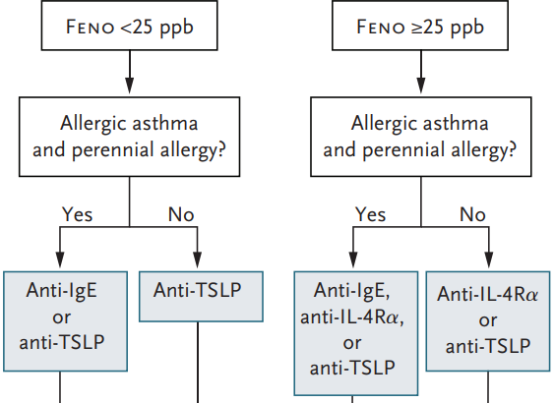

5. Monitoring and Follow-Up
- Regular FeNO Monitoring: For patients on ICS or biological therapy, FeNO should be checked periodically to assess airway inflammation. A rising FeNO level may indicate the need to escalate ICS or adjust biological therapy.
- ICS Adjustment: Consider ICS reduction in patients with stable asthma symptoms and low FeNO (< 25 ppb). However, ICS reduction is not recommended in patients with persistently elevated FeNO.

6. Conclusion
FeNO is an essential tool in managing asthma, allowing for tailored therapy based on airway inflammation. It can guide decisions on ICS dosing and the initiation of biological therapies. Regular FeNO monitoring helps optimize treatment while minimizing the risk of exacerbations.

FeNO for management of cough

The American College of Chest Physicians (CHEST) guidelines also support the use of FeNO in managing chronic cough due to asthma and non-asthmatic eosinophilic bronchitis (NAEB).
They recommend FeNO as a non-invasive measurement to evaluate airway inflammation and predict corticosteroid responsiveness

FeNO Level (ppb) | Considerations for Therapy
< 25 ppb | - Consider a cause of cough other than asthma or NAEB
≥ 25 ppb | - Consider ICS therapy for cough-variant asthma or NAEB  - Elevated FeNO suggests ongoing airway inflammation.

FENO Confounders

FeNO levels are falsely elevated  --May lead to unnecessary use of ICS | FeNO levels are falsely reduced
Allergic rhinitis | Reduced age
Nasal polyps | Obesity
Height | Smoking
Male Sex | Use of corticosteroids (inhaled and/or oral)
Consumption of dietary nitrates (caffeine, lettuce, radishes) | Bronchoconstriction
Rhinovirus in healthy people | Early allergic reactions
Morning (FeNO has diurnal variation)

References

FeNO in Asthma
Loewenthal Lola, Menzies-Gow A
Semin Respir Crit Care Med 2022;43:635–645.

Use of Fractional Exhaled Nitric Oxide to Guide the Treatment of Asthma: An Official American Thoracic Society Clinical Practice Guideline.
Khatri SB, Iaccarino JM, Barochia A, et al.
American Journal of Respiratory and Critical Care Medicine. 2021;204(10):e97-e109.

Biologic Therapies for Severe Asthma
Brusselle GG and Koppelman, GH
N Engl J Med 2022;386:157-171

Managing Chronic Cough Due to Asthma and NAEB in Adults and Adolescents: CHEST Guideline and Expert Panel Report.
Côté A, Russell RJ, Boulet LP, et al.
Chest. 2020;158(1):68-96.

Performance of Fractional Exhaled Nitric Oxide in Predicting Response to Inhaled Corticosteroids in Chronic Cough: A Meta-Analysis.
Ambrosino P, Accardo M, Mosella M, et al.
Annals of Medicine. 2021;53(1):1659-1672.

